Ngakuta Bay Community Association Newsletter #2
July 2023
Sounds Future Access Survey
This must be completed by 5pm Tuesday 11 July 2023
To all Marlborough Sounds residents.
To protect your lifestyle, business, property & leisure interests, make sure you complete the online survey on how the proposed options for future road access will impact you.
Find the survey here
soundsfutureaccess@marlborough.govt.nz

Mid-Winter Get Together
We have organised a Mid-Winter Get Together on Saturday 22 July 2023 at 3.00pm. This is a chance for everyone to catch up in a lovely warm home.
Property owners are most welcome to attend. Please bring finger food to share and your own drinks. The event will be held at Maurice Kennedy and Rosemary Balantine-Scott’s home, 6 Phillips Road, Ngakuta Bay.

Ngakuta Bay Coffee Mornings – We are looking for a venue within the bay to hold our monthly coffee meetings. The venue would have to have power and toilet facilities.
Our next coffee morning will be Thursday 7 September 2023, the venue to be confirmed. Everyone is welcome.

NBCA Membership Fees
The $20.00 membership fee for 2023 is due now. Please pay into our bank account below.
Bank Account 38-9008-0700176-000.
Our financial year runs from 1.12.22 to 30.11.23.
Thank you to the property owners who have already paid their subs for 2023. If you are unsure if you have paid the subs please contact Trish Barker our treasurer. Trish’s email is ngakutabaytreasurer@gmail.com.
Our NBCA committee is working for the benefit of all property owners, not just permanent residents

Defibrillator in the Bay
A big thank you to The Picton Health Trust for donating the money to us to upgrade our defibrillator. The defibrillator is located under Roz and Bruce Hamilton’s home at 2316 Queen Charlotte Drive.

History of the houses in Ngakuta Bay
We are still keen to record the history of all the houses in the bay. We would really appreciate it if you could send a short history of your property. Old and new photos of your property would be really appreciated. We can then slowly build up the history of the bay. The things we need to know is when the house was built, the past owners and any thing interesting about how the house was constructed. Please email this information to Ngaire Sigmund through the NBCA email address ngakutabaycommunity@gmail.com.
New Toilet Block
Progress is being made on our new toilet block. It is exciting to know we will have the facility finish by the summer holiday season. Thank you to Neil Barker for the photos.
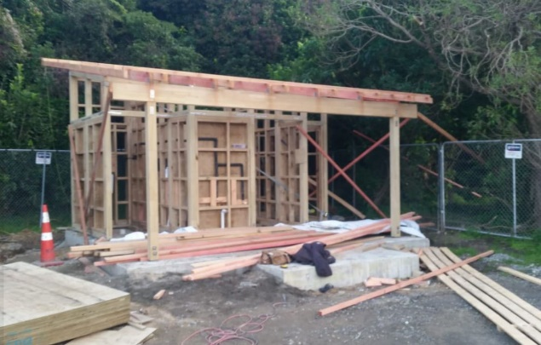
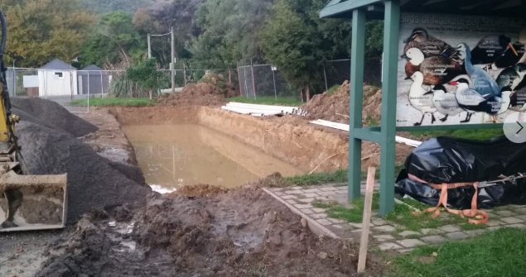

Swimming Platform
We have had the swimming platform mooring inspected and repairs by Marine Services New Zealand Ltd. We received a grant of $500.00 from the Havelock Mussel and Seafood Festival to help towards the cost of $1229.49 for this repair. A big thank you goes out to the festival.
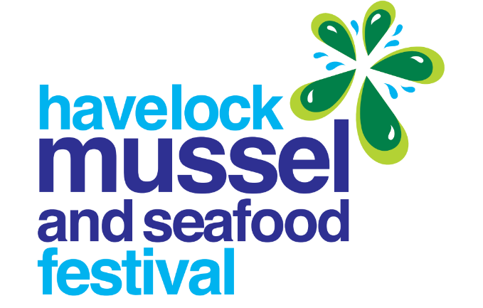
Wilding Pines in Ngakuta Bay
The Sounds Restoration Trust are coming in August 2023 to control the re-growth of wilding pines in the eastern end of Ngakuta Bay. The Ngakuta Bay Community Association will be donating $2,000 towards the total cost of approximately $12,000. Property owners are welcome to make pledges towards the costs of removing the wilding pine. Please contact Trish Barker our treasurer if you would like to contribute towards this project. Her email address is ngakutabaytreasurer@gmail.com.

Ngakuta Bay History
These photos were displayed on the Old Marlborough Facebook Page a couple of months ago by Allen Diamanti. The photos were taken in the latter half of the 19th century. The cottage shown in the first photo was owned by the Avis family who moved to Ngakuta Bay in 1858.
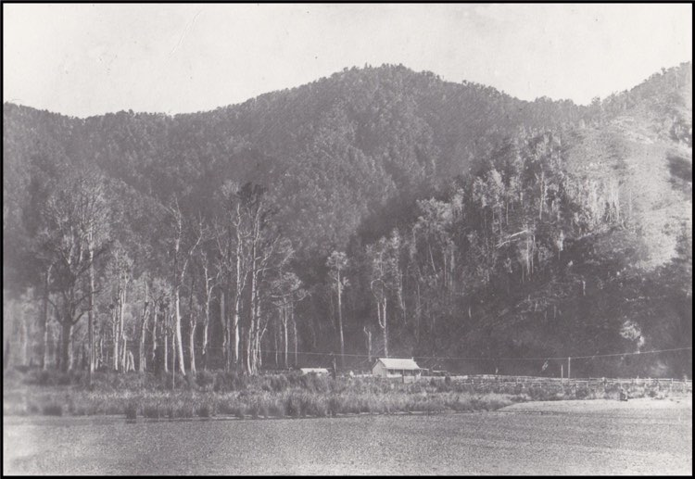
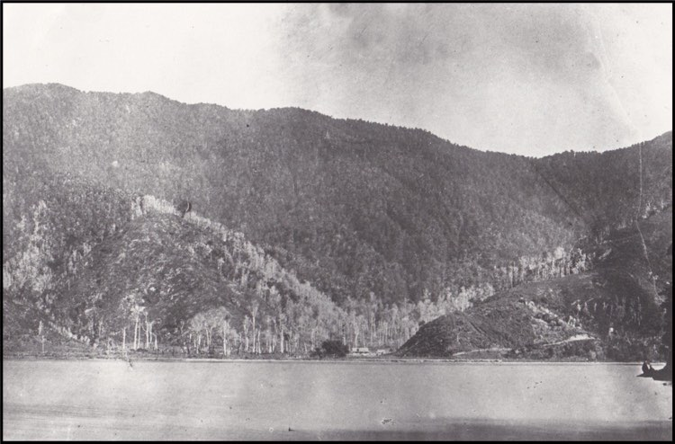

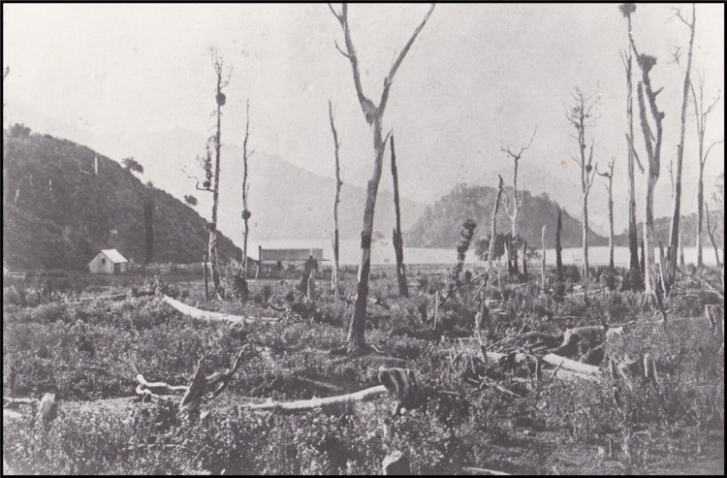

Domestic Cats
We would like to know if property owners have domestic cats in Ngakuta Bay.
If you could email us at ngakutabaycommunity@gmail.com with your name, address, name of cat, description of cat and a photo.
It is our priority to keep our traps away from where domestic cats live and roam. If by chance a domestic cat does get in a trap we want to quickly return them to their owners alive.
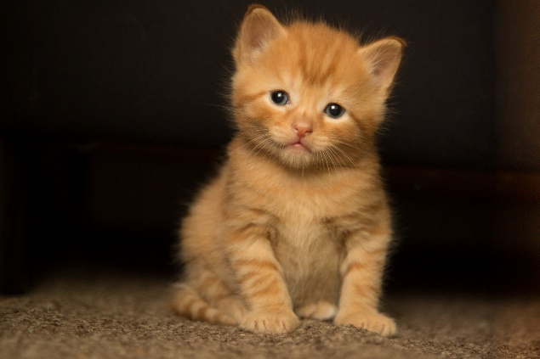

JP in our area
Chris Faulls
Smith’s Farm Holiday Park, 1419 Queen Charlotte Drive RD 1 Picton 7281
03 5742806

